HW 4 INFS 346

Eric Diaz

MC 5: ExoProtect

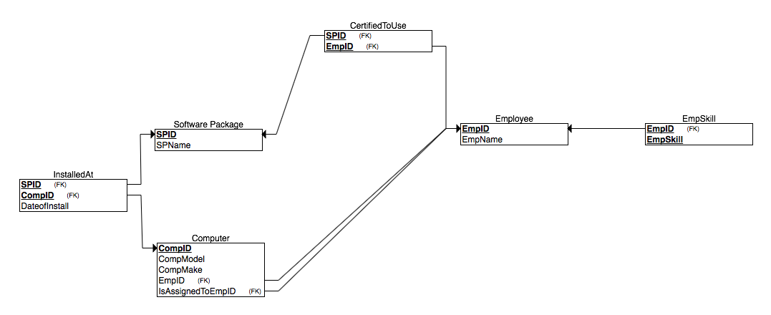

MC 6: Jones Dozers

